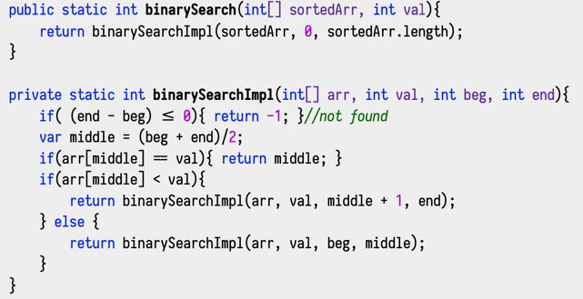

Array based Queue
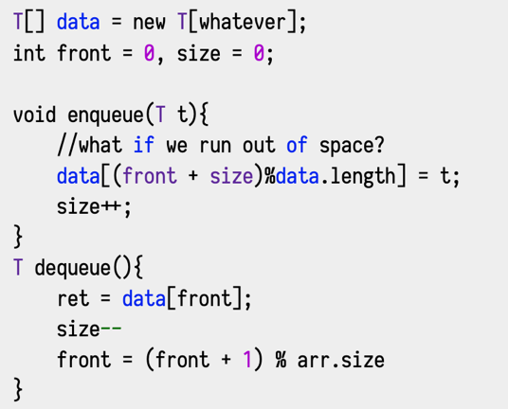

Arraylist Stack
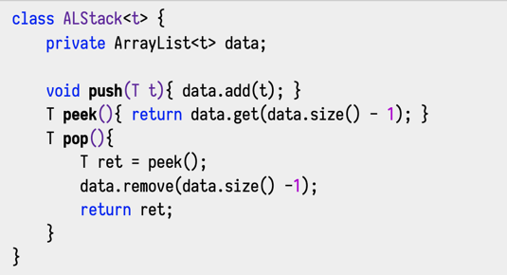

- The top of a tree is called the “root” node (CS folks draw trees upside down);
- The nodes directly below a node are its “children”;
- Nodes anywhere below a node are its “descendents”;
- The node (one node, singular) directly above a node is its “parent”;
- Any node above a node is an “ancestor”
Nodes with the same parent are siblings;
- Nodes without children are “leaf nodes”;
- Nodes with children that aren't the root are “internal nodes”;

- Any node and its descendents is a “subtree.” It's a tree that's part of another tree. We'll often talk about “the subtree rooted at n” which means to look at the tree from that node and its descendents;
- The depth of a node is the number of ancestors it has (same as the number of links to trace to get to the root). The root has depth 0;
- The height of a tree (or subtree) is the maximum depth of any node;
- An “ordered” tree is one in which there is some sort of ordering between siblings. We'll see lots of ordered trees;
- An “unordered tree” is the opposite. An “org chart” at a company is unordered there is no ordering between employees with the same
manager;

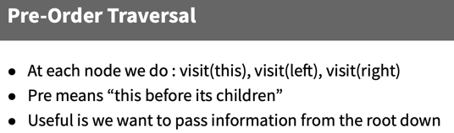
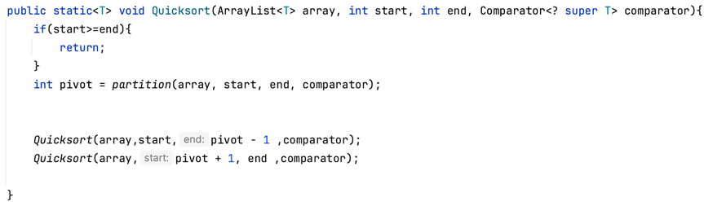
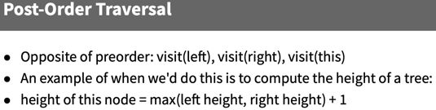
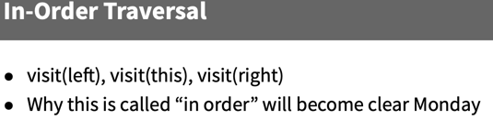
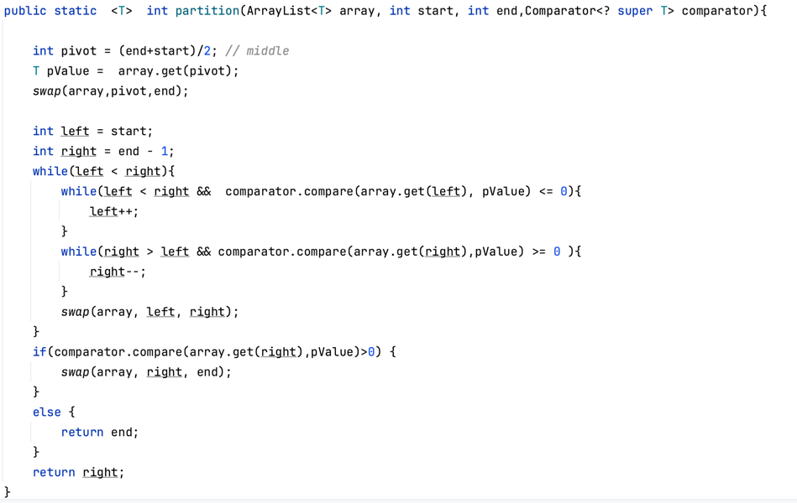
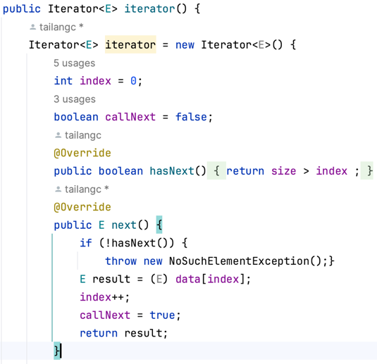
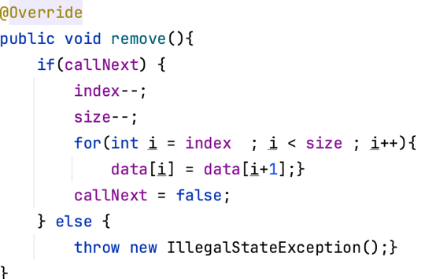
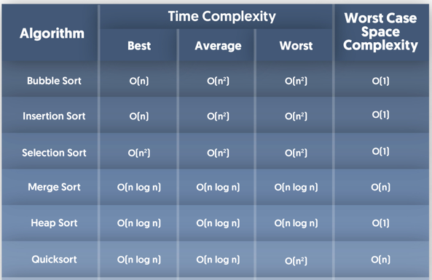
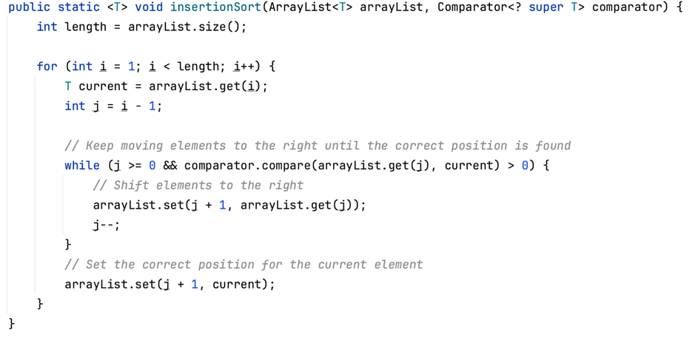
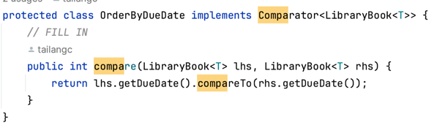
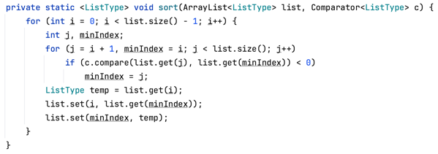
Using Comparable Interface
A comparable object is capable of comparing itself with another object. The class itself must implements the java.lang.Comparable interface to compare its instances.

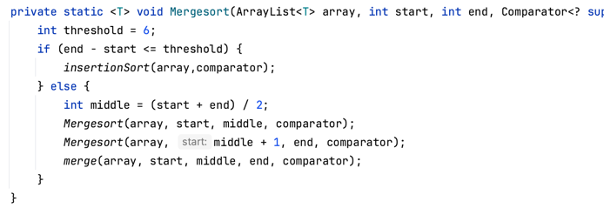

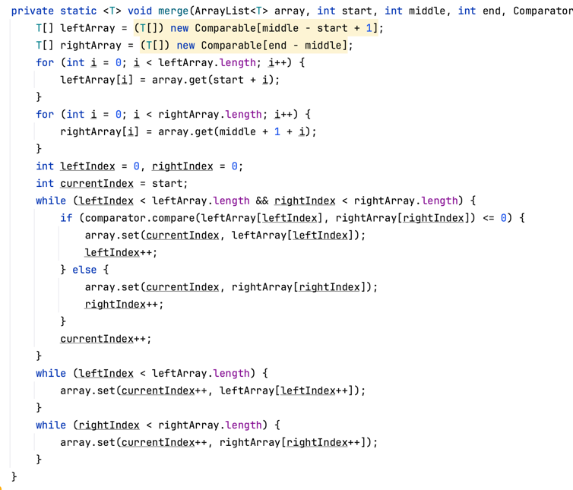
Drivers Method
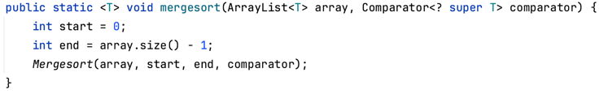
Merge/Quick Best:
In the best case, our pivot is the median value and le/right sides each have N/2 elements

Shell Sort
